Course: | Fundamentals of Programming for Business
Course code: | CS2016 | Year/Semester: | Fall 2023
Program: | BSBA,BFT | Units/Cr Hrs: | 3 Cr Hrs
Department: | FAST School of Management | Instructor: | Ms. Iman Ilyas
Course Type: | Core Course (Elective for BBA-BS AF) | Email: | Iman.ilyas@nu.edu.pk
Pre-Requisite(s): | None | Phone: | Ext. 256
Prepared By: | Dr. Zeeshan Ali | Consultation Hours: | 11:00 am – 1:00 pm
Approved By: |  | Approval Date:

COURSE DESCRIPTION
In this course, students will gain understanding of fundamentals of computer programming. Students will acquire basic programming skills such as computational thinking, problem solving, basic data types, loops, functions etc. Through practical programming activities, students will gain an appreciation of the nature of computer programming. The focus is to develop the foundation and an aptitude for programming at advanced levels.
Since, python is a general-purpose, versatile, and powerful programming language. It’s a great first language because it’s concise and easy to read. Whatever you want to do, Python can do it from web development to machine learning to data science.

COURSE OBJECTIVES
Upon successful completion of the course students should be able to:
1 | Comprehend the notion of computational thinking and understand the development of algorithms
2 | Develop problem solving and logic building skills in students.
3 | To introduce the basic concepts of programming in Python strengthening the foundation including basic data types, expressions, iterations, functions and arrays.
4 | Provide hands-on experience of implementing basic programming concepts in Python programming language.

COURSE LEARNING OUTCOMES
LO# | Learning Outcome Statement | Program Objective | Bloom’s Taxonomy Level
LO1 | Understand basic problem-solving steps and logic constructs through computational thinking | PO1 | Understand
LO2 | Design and implement algorithms to solve real world business problems and should be able to translate a problem statement into pseudo-code/Python code | PO1,  PO3,  PO5, | Analyze, Evaluate
LO3 | Apply basic programming concepts | PO1,  PO5,  PO10.4 | Apply
LO4 | Understand the GUI Programming and the real world applications of programming | PO1,  PO5,  PO10.4 | Understand, Apply

LEARNING OUTCOME ASSESSTMENT STRATEGY
Assessment Tool | LO1 | LO2 | LO3 | LO4
Assignments / Projects | 25 | 25 | 25 | 50
Quizzes | 25 | 0 | 0 | 0
Mid Term | 50 | 25 | 25 | 0
Final Exam | 0 | 50 | 50 | 50
* Percentages are meant to be viewed vertically.
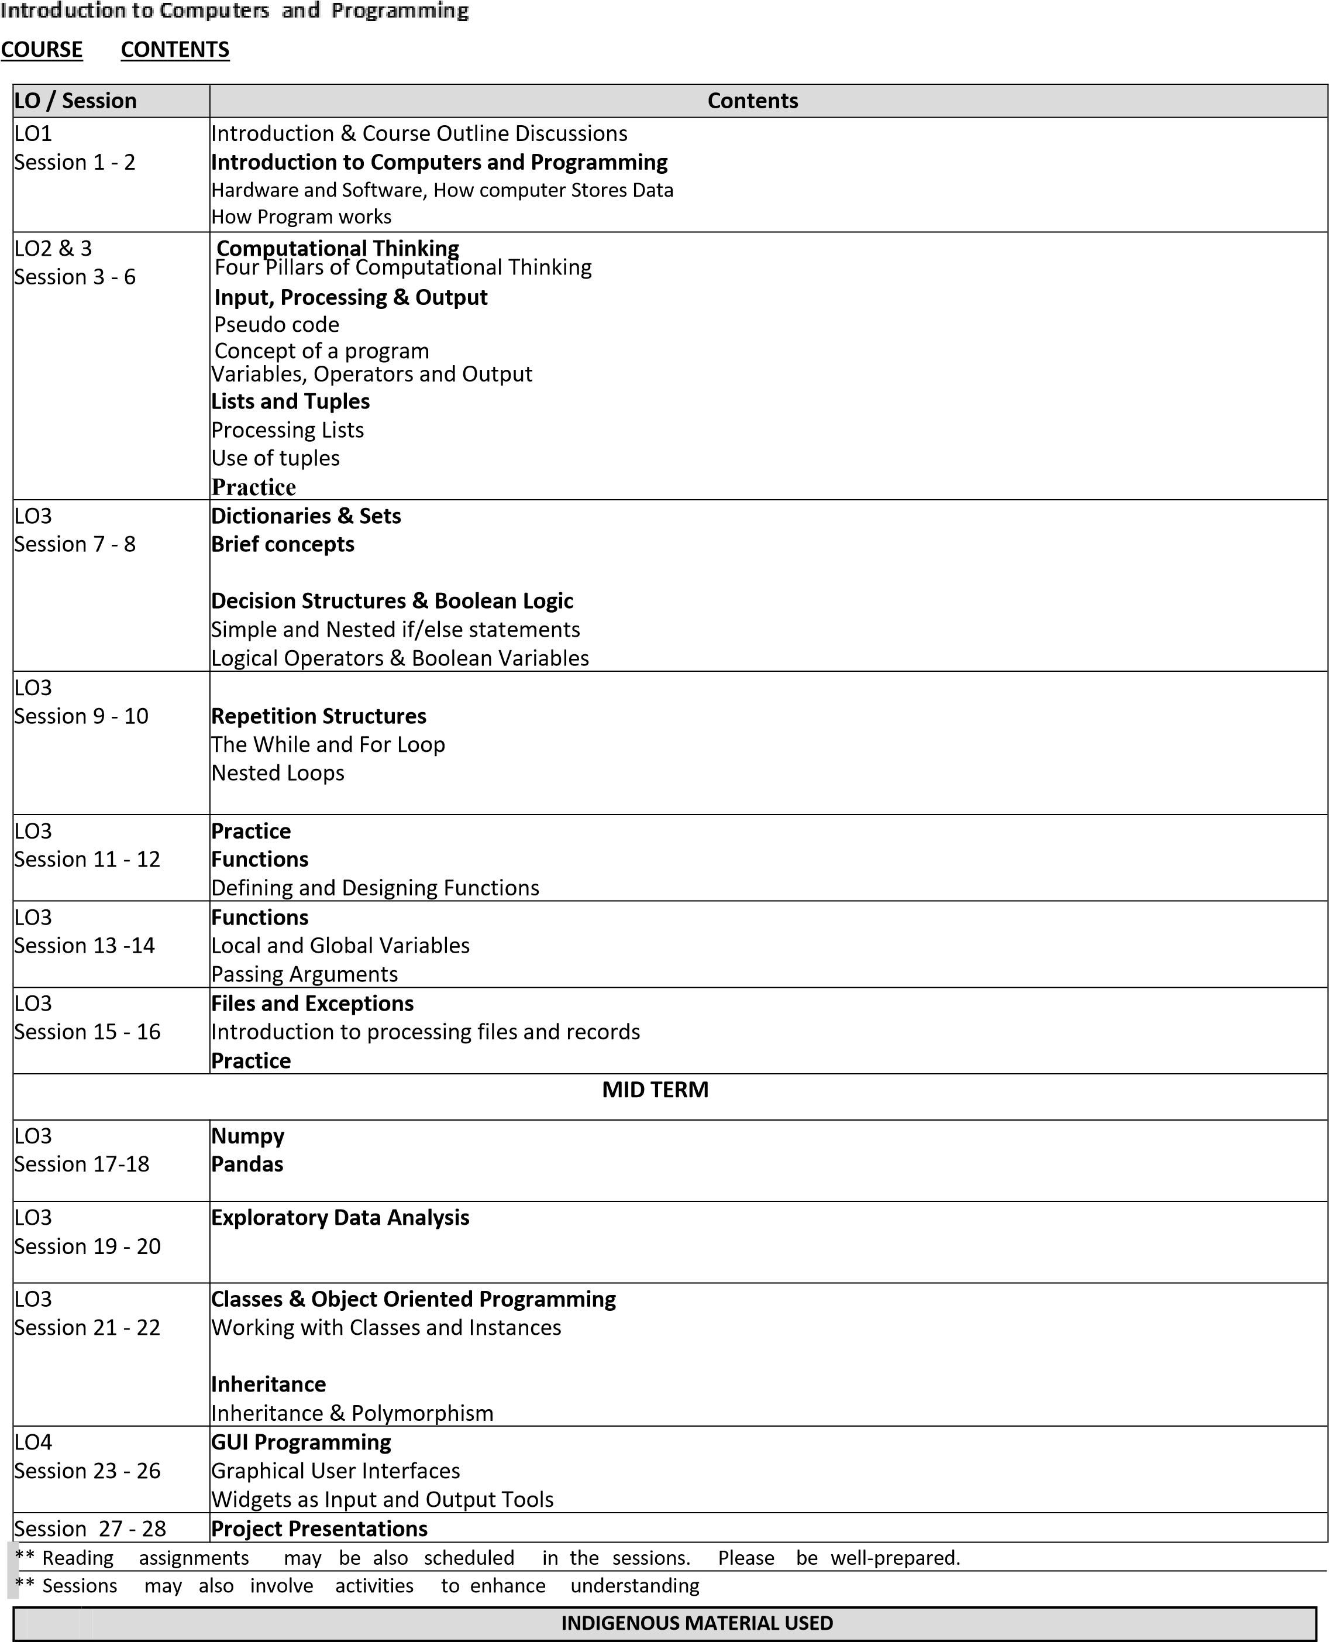

TEXTBOOK& REFERENCE MATERIAL
Primary Text:
Gaddis, T. (2021). Starting Out with Python (Fifth). Pearson Education.
Reference Books:
Downey, A. B. (2016). Think Python-How to Think Like a Computer Scientist (Second). O’Reilly.
ADMINISTRATIVE INSTRUCTIONS
S.  No | Material /Activity | Details
1. | Final Project | Explore the fundamental concepts of programming with practical application during the class lectures, assignments and the project.
2. | Guest Speaker Session | Guest speakers from the local industry are invited to give talks on Python and its applications to enlighten us with the practical applications in the industry.
3. | Local & International Case  Studies | Students are given local and international case scenarios to link the concepts and their use.
4. | Soft Wares | Familiarity with practical use of Python and its core concepts

GRADING POLICY
Grading Mechanism |  |  |  |  | Weight
Assignments & Quizzes |  |  |  |  | 15
Project |  |  |  |  | 15
Class Participation/Attendance |  |  |  |  | 05
Mid Term Exam |  |  |  |  | 15
Final Exam |  |  |  |  | 50
Grading Criteria
 | ABSOLUTE Grading | ☒ | RELATIVE Grading
** Final Grading will be relative grading, using inter-quartile range/MCA method.

Class Policies
- Please note that any exception for one student is unfair to all other students, so don’t expect any.
- Please turn off and store away cell phones, Ipads, laptops, and other electronic devices.
- Talking during lecture is not permitted. It is disrespectful and disruptive to other class members and the instructor.
- If you miss a class, it is your responsibility to determine what was covered including any administrative announcements.

Studying
The proper way of studying for this class is following ADA policy; a short description of the same is as follows
- Ahead of the class, it is is expected that you have read the relevant chapters from the textbook;
- During the class you are expected to follow the lecture, take notes and ask questions; and
- After every class you would review your notes and solve the end of chapter exercises and read the textbook.
An extensive set of practice problems is placed on the Xeon Server, make sure you cover them all. We might set a tutorial session from time to time to answer your queries about the problems/practice sets.

Attendance Policy
As you can see, almost every other session is a different topic and as such missing any classes will result in huge setback as you will lose substantial course content. Besides, owing to the interactive nature of the course, attendance is crucial. Therefore, only under unavoidable circumstances, student should think of missing a class. See university policy on minimum attendance allowed for final exams.

National University of Computer & Emerging Sciences Lahore Campus

Scholastic Dishonesty
In the classroom and in all other academic activities, students are expected to uphold the highest standards of academic integrity. Any form of scholastic dishonesty is an affront to the pursuit of knowledge and jeopardizes the quality of the degree awarded to all graduates.
What exactly is plagiarism?
- Plagiarism is a form of cheating.
- Plagiarism is using someone else’s ideas or words and saying they are your own.
If you use material from a text and do not acknowledge the source, you are committing plagiarism.

Specifically, these behaviors are often regarded as plagiarism:
- Copying directly from a text, acknowledging the source but pretending that you are paraphrasing.
- Paraphrasing or copying directly from a text without acknowledging the source.
- Copying from another student’s assignment with or without the student’s knowledge.
The following behaviors are regarded as misconduct:
- Submitting the same assignment in two different papers.
- Getting someone else to write an assignment for you.
You are also involved in misconduct if you:
- Let another student copy from your own work.  Write an assignment for another student.
Students who violate the rules on scholastic dishonesty are subject to disciplinary penalties, including the possibility of failure in the course and/or dismissal from the University. Since dishonesty harms the individual, all students, and the integrity of the University, policies on scholastic dishonesty will be strictly and actively enforced.

